**Experiment - 5**

**Aim: To add Form and various Input fields to HTML Web Page**

Form :

The HTML <form> element defines a form that is used to collect user input

<form>

...Form Elements …

</form>

* An HTML form contains **form elements**.
* Form elements are different types of input elements, like text fields, checkboxes, radio buttons, submit buttons, and more.

Input :

The <input> element is the most important form element.

The <input> element can be displayed in several ways, depending on the **type** attribute.

<form>

First name:<br>

<input type="text" name="firstname"><br>

Last name:<br>

<input type="text" name="lastname">

</form>

Table Showing form Tags

|  |  |
| --- | --- |
| **Tag** | **Description** |
| [<form>](https://www.w3schools.com/tags/tag_form.asp) | Defines an HTML form for user input |
| [<input>](https://www.w3schools.com/tags/tag_input.asp) | Defines an input control |
| [<textarea>](https://www.w3schools.com/tags/tag_textarea.asp) | Defines a multiline input control (text area) |
| [<label>](https://www.w3schools.com/tags/tag_label.asp) | Defines a label for an <input> element |
| [<fieldset>](https://www.w3schools.com/tags/tag_fieldset.asp) | Groups related elements in a form |
| [<legend>](https://www.w3schools.com/tags/tag_legend.asp) | Defines a caption for a <fieldset> element |
| [<select>](https://www.w3schools.com/tags/tag_select.asp) | Defines a drop-down list |
| [<optgroup>](https://www.w3schools.com/tags/tag_optgroup.asp) | Defines a group of related options in a drop-down list |
| [<option>](https://www.w3schools.com/tags/tag_option.asp) | Defines an option in a drop-down list |
| [<button>](https://www.w3schools.com/tags/tag_button.asp) | Defines a clickable button |
| [<datalist>](https://www.w3schools.com/tags/tag_datalist.asp) | Specifies a list of pre-defined options for input controls |
| [<output>](https://www.w3schools.com/tags/tag_output.asp) | Defines the result of a calculation |

**Output**

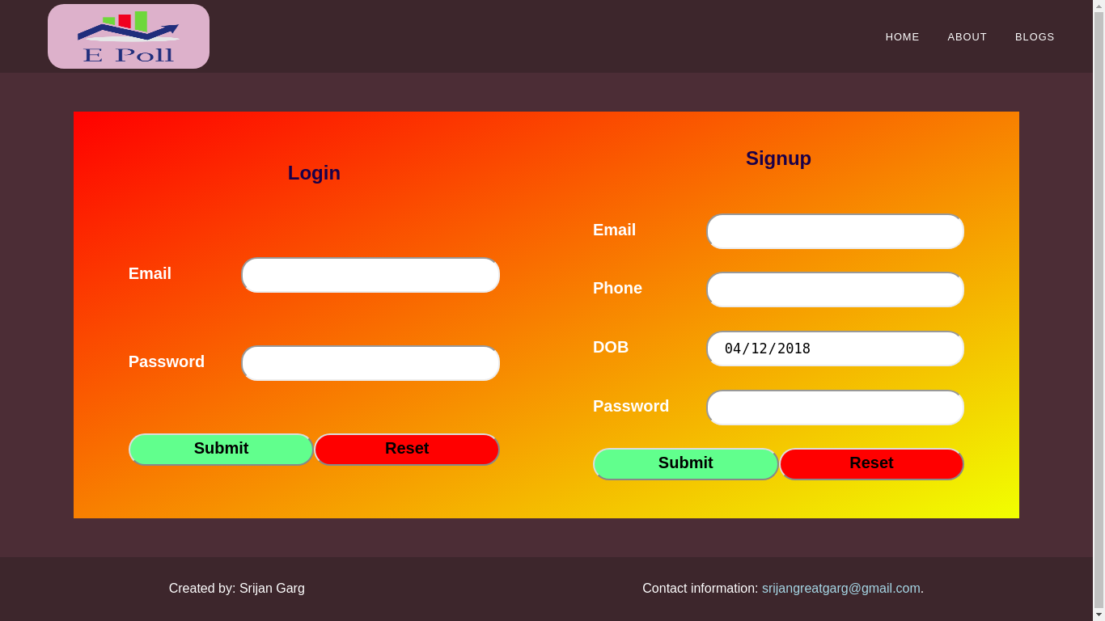

**Login and Signup forms**

**Used input types : Email, Password, Tel, Date, Submit, Reset**